Report
Resident Management System
Introduction:
This project, a Society Resident Management System, was created in C++ with object-oriented programming. By offering a straightforward and centralized platform, it seeks to address actual issues that people in a housing society face.
Residents can register, pay their bills, file complaints, purchase groceries, and participate in community events using the system. By substituting digital solutions for manual labor, utilizing file handling to store data, and utilizing OOP features like inheritance and polymorphism to provide greater structure and flexibility, it enhances day-to-day operations.
Both administrators and residents benefit from this project's ability to speed up, simplify, and improve society management.
Literature Review:
Billing systems, event booking platforms, and hospital management applications all benefit from Object-Oriented Programming (OOP) in C++, which enhances efficiency, reusability, and maintainability. These systems often use classes, inheritance, encapsulation, polymorphism, and in some cases, virtual inheritance to avoid complexities of multiple inheritance. In billing systems, OOP helps calculate and manage utility payments smoothly, while event booking systems handle registrations and payments through structured class-based designs and menus, often using vectors for dynamic data storage. Hospital and patient treatment systems, especially in emergencies, require effective decision-making and data handling—tasks well suited to C++ OOP principles. By modeling doctors, patients, and diseases as objects, and simulating disease-based consultations and treatment suggestions, these systems mirror real-world healthcare processes. Additionally, features like complaint registration can also be efficiently implemented using class structures, allowing users to submit and track their issues, making the overall system more user-friendly and responsive.

Major Features

Society Complaint System (Munawar Ali)

Implementation
This project is implemented in C++ the usage of object-orientated programming principles. It consists of 3 principal lessons:
• House: Handles residence size enters and display.
• Resident: Manages resident information inclusive of username, password, name, smartphone, and house. It additionally registers residents and saves their records to a document.
• Complaint (inherits from Resident): Allows citizens to sign up complaints with the aid of deciding on a type and describing info. Complaints are saved in a separate record.
The software helps registering new residents, signing in with username and password, submitting court cases, and viewing formerly filed complaints. It dynamically resizes the arrays used to shop residents and court cases whilst wished.
Resident and criticism details are stored in textual content documents (resident. Txt and complaint.Txt) for staying power.

OOP Features
- Classes and objects
- Encapsulation
- Inheritance
- Composition
- Exception handling
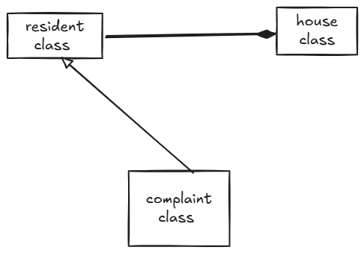

Bill Payment System: (Abdul Rehman)
Classes Overview:
- Bill: Base class with bill calculation, penalty, and payment methods.
- Electricity Bill / Gas / Security: Inherit from Bill, implement service-specific features.
- billsystem: Manages user input and calls electricity, gas, or security functions.
Key Features:
- Calculates bill based on house size.
- Applies penalty if payment is late.
- Allows service selection (guards or CCTV for security).
- Uses virtual inheritance to avoid duplication.

Grocery Store:(Bilal Ahmad)
Key Classes:
Account
Base class for Admin/User.
Stores username and password.

Product
Manages item details (name, quantity, price).
Methods: buyProduct(), updateQuantity().
Cart
Holds items (CartItem objects) added by users.
Methods: addItem(), calculateTotal().
Admin (inherits Account)
Manages products: add/update prices

User (inherits Account)
Shops and checks out.
Store
Loads/saves products from/to products.txt.
InvoiceGenerator
Creates a receipt (invoice) after purchase.
Implementation
Key Classes:
Account
Concepts used
Inheritance:
Admin and User inherit from Account (reuse username/password logic).
Encapsulation:
Data like password (in Account) and price (in Product) is private.
Polymorphism:
displayRole() behaves differently for Admin vs. User.

Hospital System:(Najia Nayab)
Hospital Management System demonstrates two categories: -
1. Register patient &amp; Book Doctor:
This feature asks the user to select a disease then the doctor is Appointed along with suggested treatment or prescribe medicine without having doctor’s booking.
2. Book Emergency:
When selected an available doctor at emergency bases is booked for emergency situation.
- Object Composition:
Patient and Doctors are having a has a relationship with main class Hospital.
- Dynamic Array:
Doctors are added dynamically to available at run time.
- Static Members:
Class hospital has static data members max_doctors, max_patient,
max_diseases used in the code for easy access.
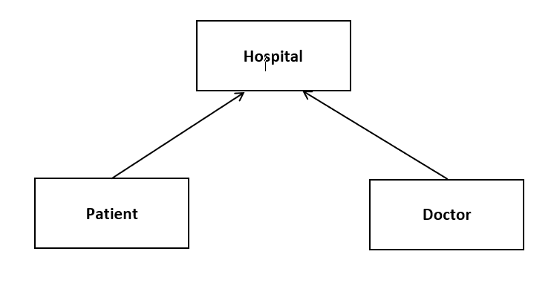

Event Management:(Aliya Ashraf)
Main Classes:
- Event: Stores event info (ID, name, date, capacity, ticket type/price).
- EventManager: Manages the list of events and booking logic.
- Member: Represents a user interacting with the system.
Features:
- Add Events: Admin (via code) adds events with ID, name, date, capacity, type, and price.
- Book Ticket: Users book available events; system checks for same-day double bookings.
- Cancel Booking: Removes a booking if it exists.
- Booking History: Shows all past bookings of the current user.
Code Concepts Used:
- Classes and Objects
- Vectors
- String and User Input
- Conditional Logic and Loops

Electricity Gas Bill

Billsystem Security

